WEB TECHNOLOGY

LAB MANUAL

LPCIT-107

Submitted by-

Kirandeep Kaur

URN - 1905353

CRN - 1921140

Submitted to-

Pf. Hanit Karwal

INDEX

|  |  |  |
| --- | --- | --- |
| Sr No | TITLE | Page No. |
| 1.  2.      3.    4.    5.    6.  7. | Create a simple web page by writing HTML using a simple text editor, Notepad. Demonstrate the following components of the web page: Page titles and Headings Paragraphs and Inline images.  Demonstrate the use of Links, Lists and Tables in HTML. You should be able to link separate pages and create named links within a document, using them to build a “table of contents”.  Create simple Forms in HTML and demonstrate the use of various form elements like input box, textarea, submit and radio buttons etc.  Demonstrate the use of cascading style sheets (CSS) (inline, internal and external) to specify various aspects of style, such as colours and text fonts and sizes, in HTML document.    Creation of Web pages using HTML5 and CSS3.  Demonstrate the use of Bootstrap Framework.  Creating web pages using PHP. | 3-4  5-8  9-11  12-15  16-18  19-23  23-28 |

Practical 1.

Create a simple web page by writing HTML using a simple text editor, Notepad. Demonstrate the following components of the web page: Page titles and Headings Paragraphs and Inline images.

Code-

<!DOCTYPE html>

<html>

<body>

<h1>Guru Nanak Dev Engineering College,Ludhiana</h1>

<p1>Guru Nanak Dev Engineering College, one of the prestigious, oldest and minority institution of Northern India, was established under the aegis of Nankana Sahib Education Trust (NSET) in 1956.</p1>

<imgsrc="https://www.logolynx.com/images/logolynx/9f/9f2c4042d28462d69f738e6018bb4ff9.jpeg" alt="GNDEC LOGO">

</body>

</html>

**Output:** 

Practical 2.

Demonstrate the use of Links, Lists and Tables in HTML. You should be able to link separate pages and create named links within a document, using them to build a “table of contents”.

**Code:**

<!DOCTYPE html>

<html>

<head>

<body style="background-color:lightblue;">

<h1>Welcome to Food Planet</h1>

<img src="https://cdn3.vectorstock.com/i/1000x1000/73/07/cooking-and-restaurant-logo-design-vector-29707307.jpg" alt="food planet" width="500" height="600">

<p><a href="https://www.zomato.com/cs/phagwara/love-food-planet-phagwara-locality/order">Visit us online!</a></p>

<style>

table, th, td {

border: 1px solid black;

border-collapse: collapse;

}

</style>

</head>

<h2>MENU</h2>

<p> Here is the menu for you. </p>

<table style="width:100%">

<tr>

<th>Items</th>

<th>Size</th>

<th>Price</th>

</tr>

<tr>

<td>Veg Noodles</td>

<td>Full</td>

<td>150</td>

</tr>

<tr>

<td>Grilled Sandwich</td>

<td>Small</td>

<td>80</td>

</tr>

<tr>

<td>Manchurian</td>

<td>Full</td>

<td>100</td>

</tr>

</table>

<h3>MEALS</h3>

<ul>

<li>Full Breakfast - 350/-</li>

<li>LUNCH - 500/-</li>

<li>DINNER WITH FAMILY - 1200/-</li>

</ul>

<h3> SPECIAL ICE CREAM DESSERTS</h3>

<ol>

<li>Butter Scotch - 120/- </li>

<li>Mixed Fruits - 160/- </li>

<li>Chocolate - 60/- </li>

</ol>

<img src="https://encrypted-tbn0.gstatic.com/images?q=tbn:ANd9GcQp-3m5VwUiISsryCy6loIyXbjsuBhB4pwtLQ&usqp=CAU" alt="food planet">

</body>

</html>

**Output:**  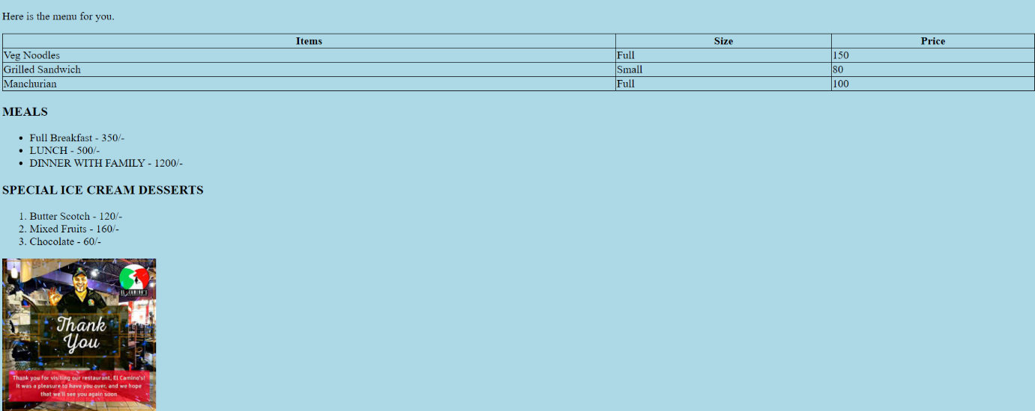

Practical 3.

Create simple Forms in HTML and demonstrate the use of various form elements like input box, textarea, submit and radio buttons etc.

<!DOCTYPE html>

<html>

<body style="background-color:LightBlue;">

<img src="C:\Users\Kirandeep\DownloadC:\Users\Kirandeep\Downloads" alt="logo" style="float:left;width:54px;height:54px;">

<h1><b><center>REGISTRATION FORM </center></b></h1>

<form action="/action_page.php">

<br> <br>

<label for="siblings"> Siblings Attending</label>

<input type="checkbox" id="siblings" name="siblings" value="Yes"><br> <br>

<label for="fname">Name of Child:</label>

<input type="text" id="fname" name="fname"><br> <br>

<label for="age"> Age:</label>

<input type="text" id="age" name="age"><br> <br>

<label for = "dob"> DOB </label>

<input type="text" id="dob" name=""><dob> <br> <br>

<label for = "gender">Gender </label> <br>

<input type="radio" id="male" name="gender" value="male">

<label for="male">Male</label><br>

<input type="radio" id="female" name="gender" value="female">

<label for="female">Female</label><br>

<input type="radio" id="other" name="gender" value="other">

<label for="other">Other</label> <br> <br>

<label for="level"> Level:</label> <br>

<input type="checkbox" id="level" name="level" value="Beginner">

<label for="level"> </label>Beginner<br>

<input type="checkbox" id="level" name="level" value="Intermediate">

<label for="level"> </label>Intermediate<br>

<input type="checkbox" id="level" name="level" value="Advanced">

<label for="level"> </label>Advanced<br> <br>

<label for="parents">Parent(s)/Guardian(s):</label>

<input type="text" id="parents" name="parents"><br> <br>

<label for="address">Address:</label>

<input type="text" id="address" name="address"><br> <br>

<label for="email">E-mail:</label>

<input type="text" id="email" name="email"><br> <br>

<label for="contact">Contact No.:</label>

<input type="text" id="contact" name="contact"><br> <br>

<label for="medicalCondition">Medical Condition(s):</label>

<input type="text" id="medicalCondition" name="medicalCondition"><br><br> <br>

<textarea name="Declaration:" rows="10" cols="200">I,________{Parent(s)/Guardian(s) name }hereby certify to the best of my knowledge that the above information is true and accurate.I understand that in the event that any informationis found to be false or misleading,the applicant can be disqualified and all fees fortifeited at One Touch Football Academy's discretion.Any information provided to One Touch Football Academy will be treated with the strictest of confidence.

I understand that the fees must be paid in full prior to my child attending the academy and that payment of fees confirms my registerationand acknowlwdgement that I have read, understood and agreed to One Touch Football Academy's Terms and Conditions. </textarea> <br>

<br><br>

<label for = "signature"> Parent(s)/Guardian(s) Signature: </label>

<input type="text" id="signature" name="signature"> <br>

<label for = "date"> Date: </label>

<input type="text" id="date" name="date"> <br> <br> <br> <br>

<input type="submit" value="Submit">

</form>

</body>

</html>

**Output:**

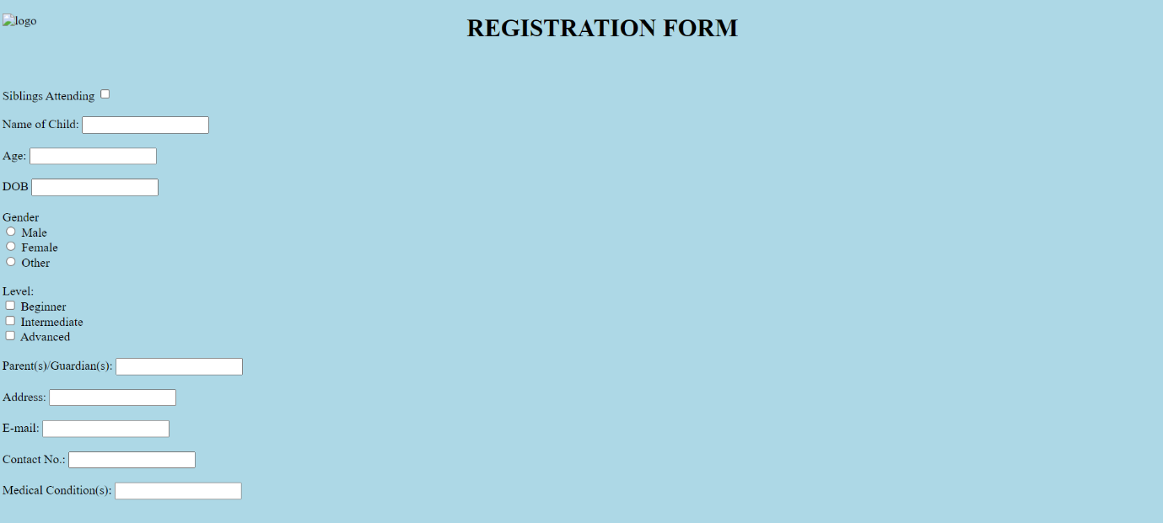 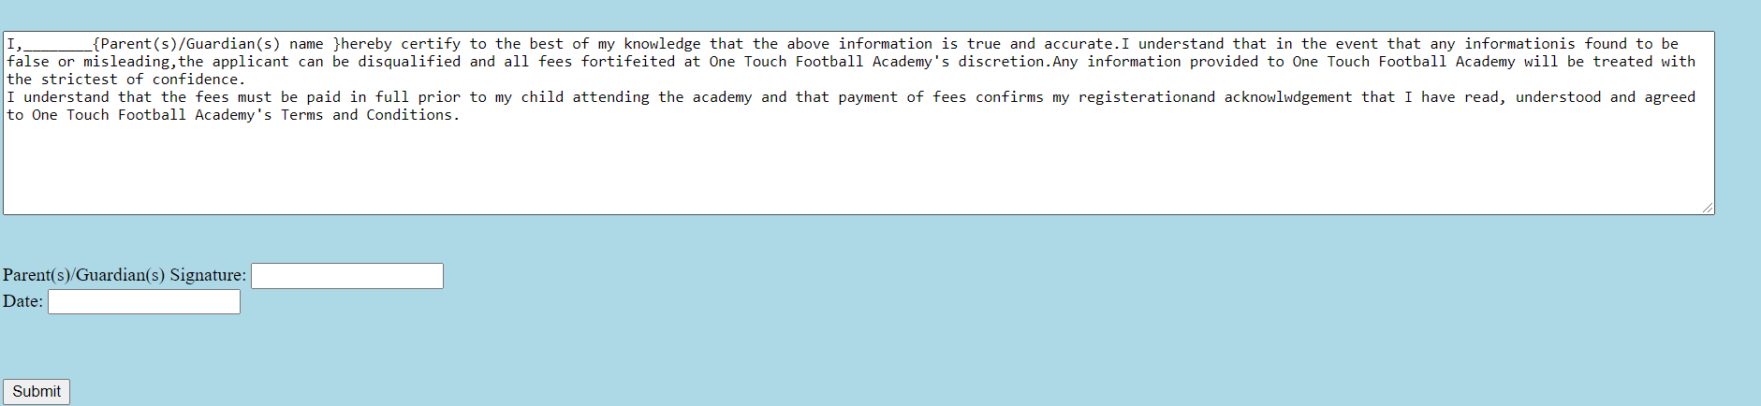

Practical 4.

Demonstrate the use of cascading style sheets (CSS) (inline, internal and external) to specify various aspects of style, such as colours and text fonts and sizes, in HTML document.

<!DOCTYPE html>

<html>

<head>

<style>

<left><img src="study.jpg" alt="logo" width="260" height="145"></left>

.nav {

background-color: yellow;

list-style-type: none;

text-align: center;

margin: 0;

padding: 0;

}

.nav li {

display: inline-block;

font-size: 20px;

padding: 20px;

}

h1 {

background-color: blue;

}

div {

background-color: lightblue;

font-size: 30px;

p.double {border-style: double;}

}

p {

background-color: lightyellow;

font-family: "Brush Script MT", serif;

font-size: 20px;

}

p1 {

border: 1px solid gray;

padding: 8px;

backgroung-color : white;

font-size: 14px;

font-family: "Lucida Console", "Courier New", monospace;

text-indent: 50px;

text-align: justify;

letter-spacing: 3px;

}

</style>

</head>

<body>

<h1>Tensed for your child's future?<br> Worry not!!</h1>

<div>

<center>"WELCOME TO EDUSYS"</center>

<p> Welcome to the extremely efficient, systematic,comprehensive and sophisticated yet userfriendly automated digital environment called'EduSys',an ERP solution specifically for K-12 Educational Institutions.</p>

<p1><center> <bold>EDUSYS SOLUTIONS CAN BE INNOVATELY POWERED TO:</bold></center>

<ul>

<li>Public/government schools</li>

<li>Independent/private schools</li>

<li>International schools</li>

<li>National open schools</li>

</ul>

This sysytem effictively brings the education stakeholders together on a common interactive patform thereby fostering mutual trust among them and building a solid education community.<br>

This is an excellent school technology platform , with inbuilt mobile app and ERP to connect& communicate with students and teachers. EduSys enables schools to adopt technology in the most user-friendly and cost-effective manner.

</p1>

</div>

<ul class="nav">

<li><a href="#home">Home</a></li>

<li><a href="#about">About Us</a></li>

<li><a href="#clients">Our Clients</a></li>

<li><a href="#contact">Contact Us</a></li>

</ul>

</body>

</html>

**Output:**

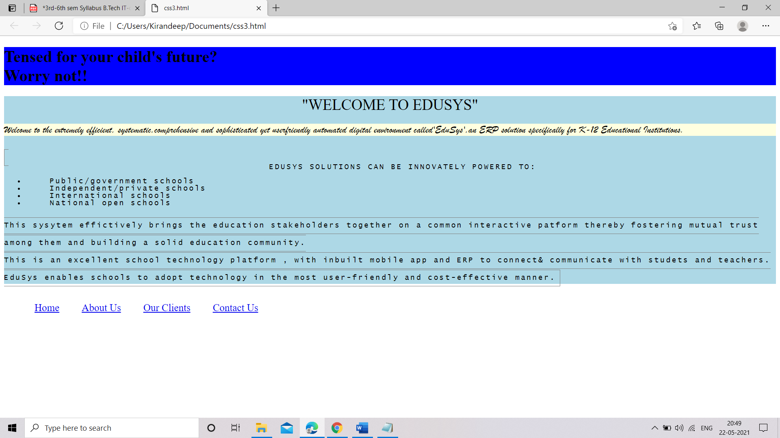

Practical 5.

Creation of Web pages using HTML5 and CSS3.

<!DOCTYPE html>

<html>

<head>

<style>

#borderimg {

border: 10px solid transparent;

padding: 15px;

border-image: url(border.png) 30 round;

}

html{

background-image: url(img_flwr.gif), url(paper.gif);

background-position: right bottom, left top;

background-repeat: no-repeat, repeat;

padding: 15px;

}

article {

column-count: 3;

column-gap: 40px;

column-rule: 1px dashed grey;

}

figcaption {

text-align: center;

font-style: italic;

font-size: smaller;

}

#example1 {

background: url(paper.gif) left top repeat;

padding: 15px;

}

</style>

</head>

<body><center>

<p id="borderimg" style="color: black; font-family: Times New Roman; font-size: 25px;">The Tribune</p>

<canvas id="myCanvas" width="700" height="30" style="border:1px solid black;"></canvas></center>

<script>

var canvas = document.getElementById("myCanvas");

var ctx = canvas.getContext("2d");

ctx.font = "15px Comic Sans MS";

ctx.fillStyle = "red";

ctx.textAlign = "center";

ctx.fillText("Trusted Since 1895", canvas.width/2, canvas.height/2);

</script>

<br>

<div class="container">

<article>

<p><h4> Coronavirus in India live updates: UP extends partial corona curfew till 7 am on May 31

</h4>

The daily rise in coronavirus cases in India remained below 3 lakh for the fifth consecutive day with 2.5 lakh new cases recorded in a single day, according to health ministry's updated data on Saturday. This as deaths remained over 4,000. The total cases have now climbed to 2,62,89,290. The cumulative number of Covid-19 vaccine doses administered in the country stands at 19,33,72,819. Stay here for all live updates on coronavirus from India and around the world</p>

<p><h4>Covid-19: Uttar Pradesh extends lockdown till May 31 </h4>

Madhya Pradesh has registered 3,844 new Covid cases, 9,327 recoveries and 89 deaths in the last 24 hours. The total number of cases stands at 7,60,963 and total recoveries at 6,91,427. The state's current death toll is 7,483 and the number of active cases is 62,053 now.

</p>

</body>

</html>

**Output:**

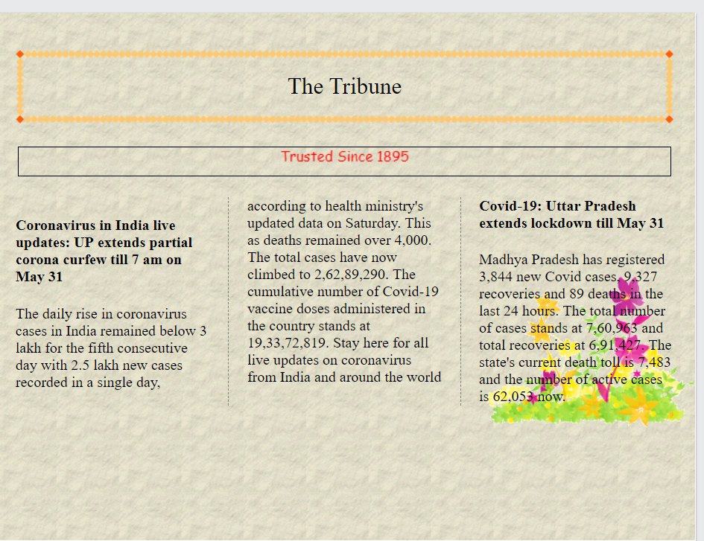

Practical 6.

Demonstrate the use of Bootstrap Framework.

<!DOCTYPE html>

<html lang="en">

<head>

<meta charset="UTF-8" />

<meta http-equiv="X-UA-Compatible" content="IE=edge" />

<meta name="viewport" content="width=device-width, initial-scale=1.0" />

<title>Practical 6</title>

<link

rel="stylesheet"

href="https://cdn.jsdelivr.net/npm/bootstrap@4.6.0/dist/css/bootstrap.min.css"

integrity="sha384-B0vP5xmATw1+K9KRQjQERJvTumQW0nPEzvF6L/Z6nronJ3oUOFUFpCjEUQouq2+l"

crossorigin="anonymous"

/>

</head>

<body style="padding: 50px">

<nav class="navbar navbar-expand-lg navbar-dark bg-dark">

<a class="navbar-brand" href="#">Taskbar</a>

<button

class="navbar-toggler"

type="button"

data-toggle="collapse"

data-target="#navbarTogglerDemo02"

aria-controls="navbarTogglerDemo02"

aria-expanded="false"

aria-label="Toggle navigation"

>

<span class="navbar-toggler-icon"></span>

</button>

<div class="collapse navbar-collapse" id="navbarTogglerDemo02">

<ul class="navbar-nav mr-auto mt-2 mt-lg-0">

<li class="nav-item active">

<a class="nav-link" href="#"

>Home <span class="sr-only">(current)</span></a

>

</li>

<li class="nav-item">

<a class="nav-link" href="#">Link</a>

</li>

<li class="nav-item">

<a

class="nav-link disabled"

href="#"

tabindex="-1"

aria-disabled="true"

>Disabled</a

>

</li>

</ul>

<form class="form-inline my-2 my-lg-0">

<input

class="form-control mr-sm-2"

type="search"

placeholder="Search"

/>

<button class="btn btn-outline-success my-2 my-sm-0" type="submit">

Search

</button>

</form>

</div>

</nav>

<br />

<div class="alert alert-success" role="alert">

<h4 class="alert-heading">You did it! </h4>

<p>

You have filled all the necessary details.Now you have to wait till further confirmations come.We will keep you updated.

</p>

<hr />

<p class="mb-0">

Fill these last details to confirm your registration. Make sure to fill it correctly and details should be latest.

</p>

</div>

<br />

<form class="needs-validation" novalidate style="margin: 0 50px">

<div class="form-row">

<div class="col-md-6 mb-3">

<label for="validationTooltip01">First name</label>

<input

type="text"

class="form-control"

id="validationTooltip01"

placeholder="Erica"

required

/>

<div class="valid-tooltip">Looks good! </div>

</div>

<div class="col-md-6 mb-3">

<label for="validationTooltip02">Last name</label>

<input

type="text"

class="form-control"

id="validationTooltip02"

placeholder="Mathew"

required

/>

<div class="valid-tooltip">Looks good! </div>

</div>

</div>

<div class="form-row">

<div class="col-md-6 mb-3">

<label for="validationTooltip03">City</label>

<input

type="text"

class="form-control"

id="validationTooltip03"

required

/>

<div class="invalid-tooltip">Please provide a valid city. </div>

</div>

<div class="col-md-3 mb-3">

<label for="validationTooltip04">State</label>

<select class="custom-select" id="validationTooltip04" required>

<option selected disabled value="">Choose...</option>

<option>...</option>

</select>

<div class="invalid-tooltip">Please select a valid state. </div>

</div>

<div class="col-md-3 mb-3">

<label for="validationTooltip05">Pin code</label>

<input

type="text"

class="form-control"

id="validationTooltip05"

required

/>

<div class="invalid-tooltip">Please provide a valid pincode.</div>

</div>

</div>

<button class="btn btn-primary" type="submit">Submit form</button>

</form>

</body>

</html>

**Output:**

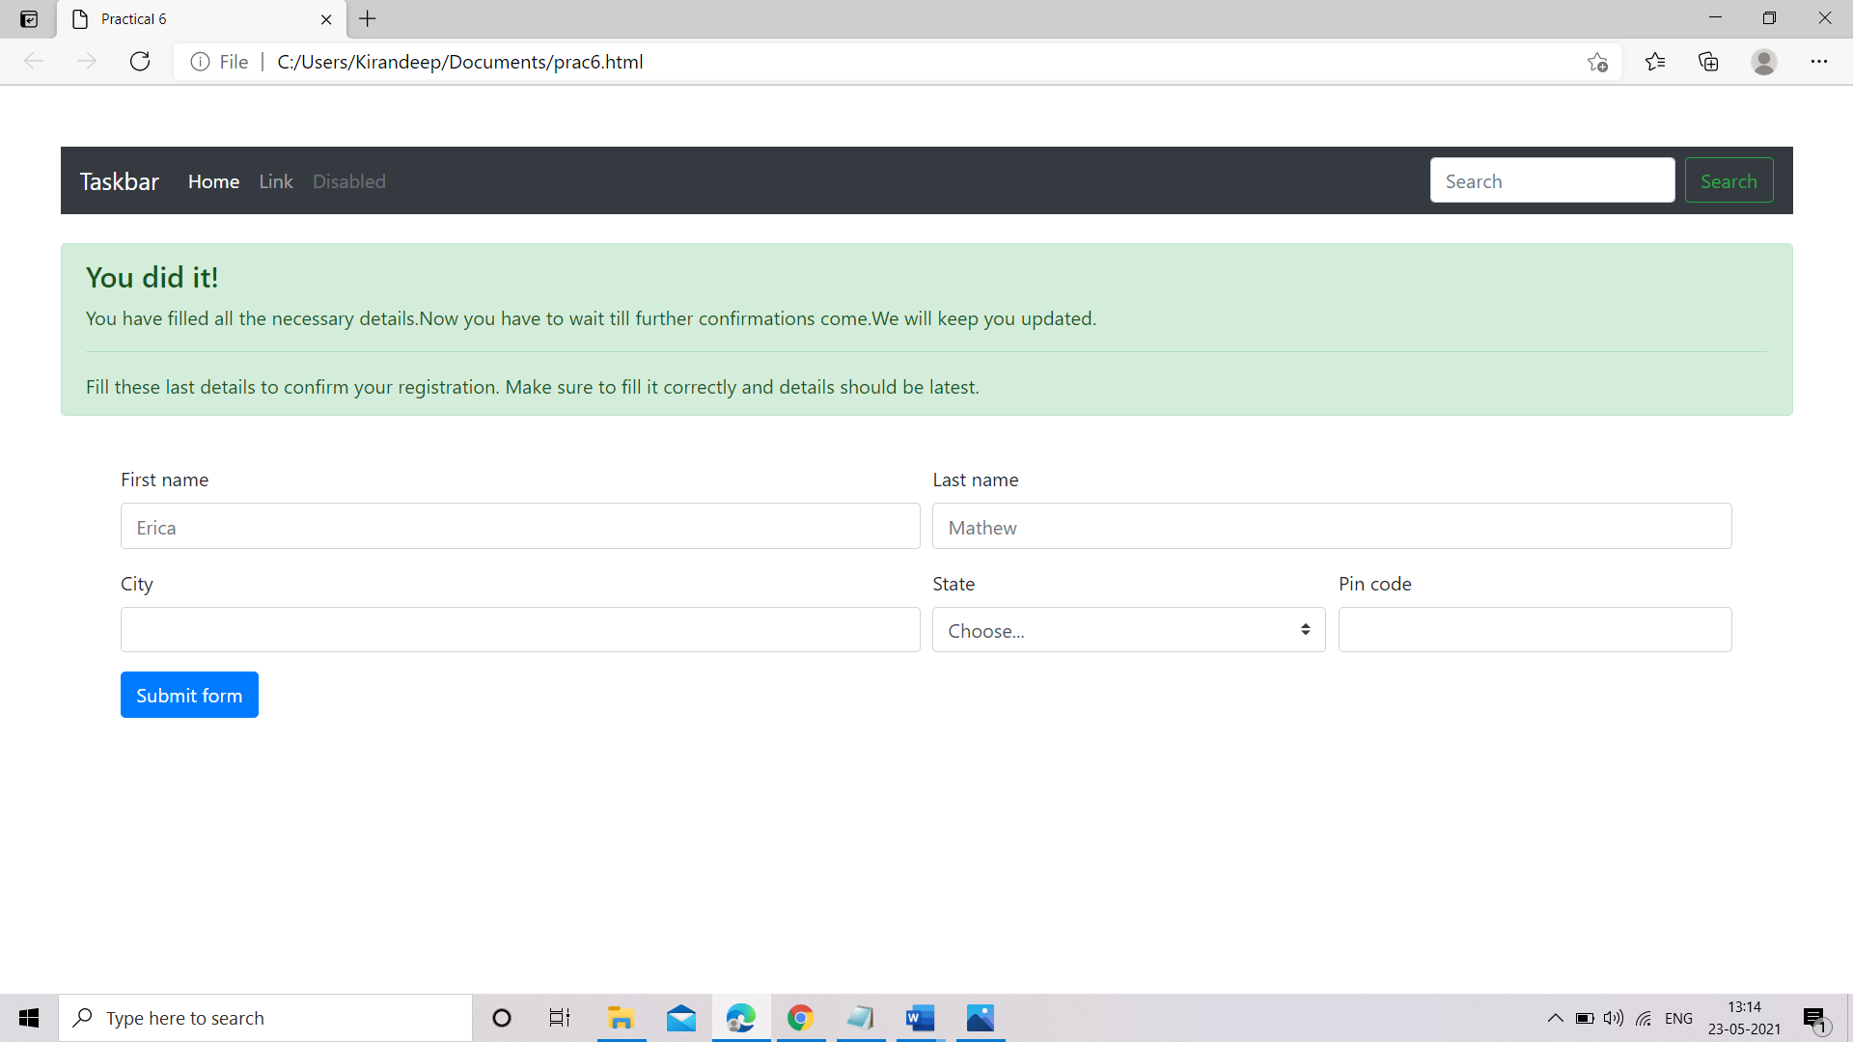

**Practical 7**.

Creating web pages using PHP.

<!DOCTYPE html>

<html lang="en">

  <head>

    <meta charset="UTF-8" />

    <meta http-equiv="X-UA-Compatible" content="IE=edge" />

    <meta name="viewport" content="width=device-width, initial-scale=1.0" />

    <title>Practical 7</title>

    <link rel="stylesheet" href="./Practical-7.css" />

  </head>

  <body>

    <div class="contact-title">

      <h1>Welcome To This Website</h1>

      <h2>We Are Happy To Help You</h2>

    </div>

    <div class="contact-form">

      <form action="Practical-7.php" method="POST" id="contact-form">

        <input

          type="text"

          name="name"

          class="form-control"

          placeholder="Your Name"

          required

        />

        <br />

        <input

          type="email"

          name="email"

          class="form-control"

          placeholder="Your Email"

          required

        />

        <br />

        <textarea

          name="message"

          class="form-control"

          placeholder="Message"

          rows="4"

          required

        ></textarea>

        <br />

        <input type="submit" class="form-control submit" value="Send message" />

      </form>

    </div>

  </body>

</html>

CSS:

body {

  margin: 0;

  padding: 0;

  text-align: center;

  background: rgb(34, 36, 0);

  background: linear-gradient(

    215deg,

    rgba(34, 36, 0, 1) 6%,

    rgba (9, 121, 118, 1) 51%,

    rgba 132, 0, 255, 1) 86%

  );

  background-repeat: no-repeat;

  height: 100%;

  background-attachment: fixed;

  background-position: center;

}

.contact-title {

  margin-top: 100px;

  color: #fff;

  text-transform: uppercase;

  transition: all 4s ease-in-out;

}

.contact-title h1 {

  font-size: 32px;

  line-height: 10px;

}

.contact-title h2 {

  font-size: 16px;

}

form {

  margin-top: 50px;

  transition: all 4s ease-in-out;

}

.form-control {

  width: 600px;

  background: transparent;

  border: none;

  outline: none;

  border-bottom: 1px solid #333;

  color: #fff;

  font-size: 18px;

  margin-bottom: 16px;

}

input {

  height: 45px;

}

form .submit {

  background: #ff5722;

  border-color: transparent;

  color: #fff;

  font-size: 20px;

  font-weight: bold;

  letter-spacing: 2px;

  height: 50px;

  margin-top: 20px;

}

form. submit: hover {

  background-color: #f44;

  cursor: pointer;

}

PHP:

<?php

    $name=$_POST['name'];

    $visitor_email=$_POST['email'];

    $message=$_POST['message'];

[$email_from='kirandeep1921140@gndec.ac.in](mailto:$email_from='guriqbal1921032@gndec.ac.in)';

    $email_subject="New Form Submission";

    $email_body="User Name: $name.\n"."User Email: $visitor_email.\n"."User Message: $message.\n";

[$to="kumarsharan1165@gmail.com](mailto:$to=%22kumarsharan1165@gmail.com)";

    $headers="From: $email_from \r\n";

    $headers .="Reply-To: $visitor_email \r\n";

    mail ($to, $email_subject, $email_body, $headers);

    header("Location: Practical-7.html");

?>

**Output:**

